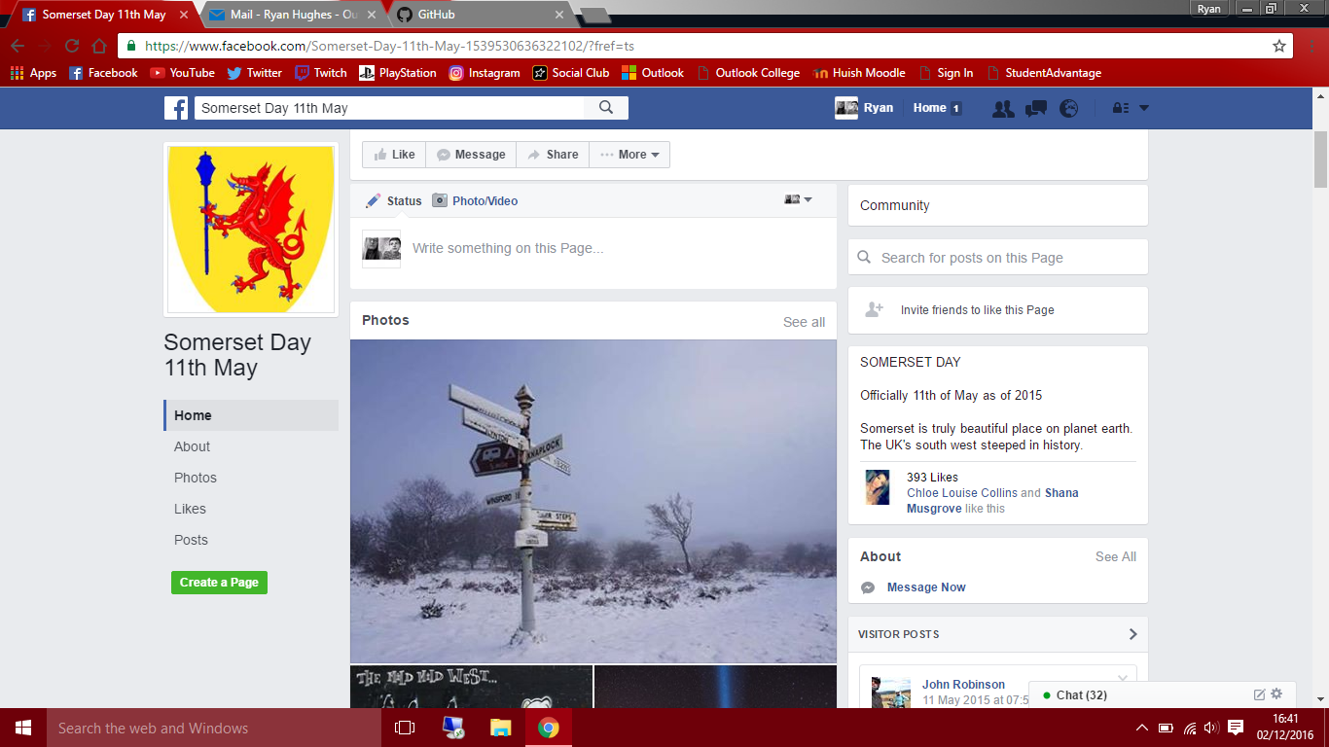**Media Research**

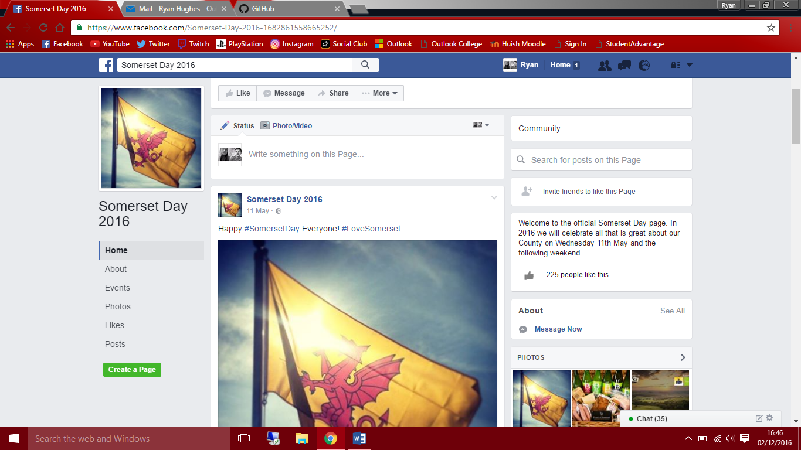Uses basic Somerset flag as logo

Vague description

Lack of content

Engaging cover photo

No contact method – doesn’t encourage businesses or locals to create an event

Detailed description of event

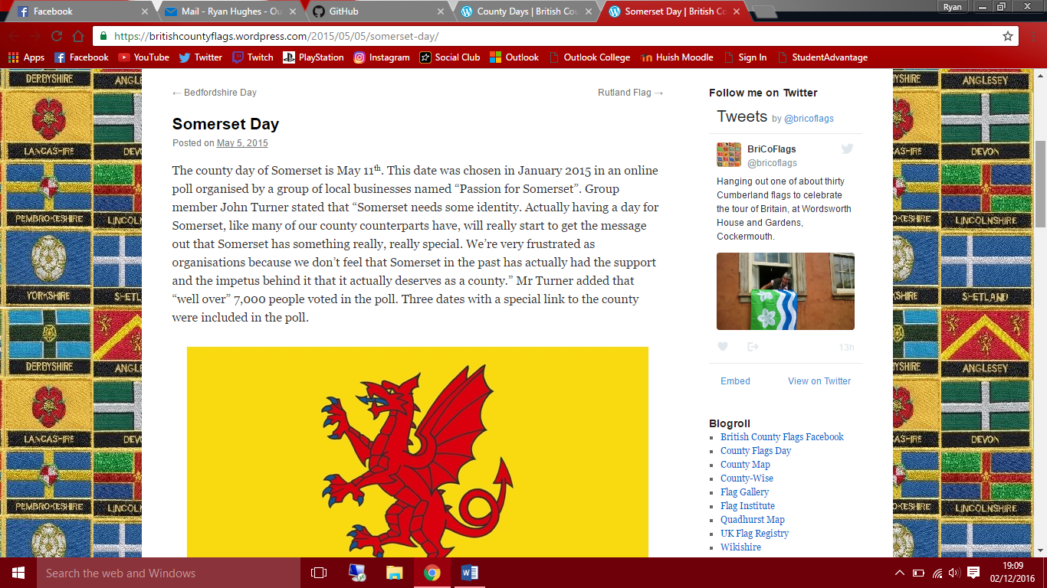Historic information – reason for date

Passion for Somerset – main Somerset day organisers

Few tweets and interaction

Lack of content – no images or videos to engage people

Event page specific for area

Lots of detail and content

Links to create an event

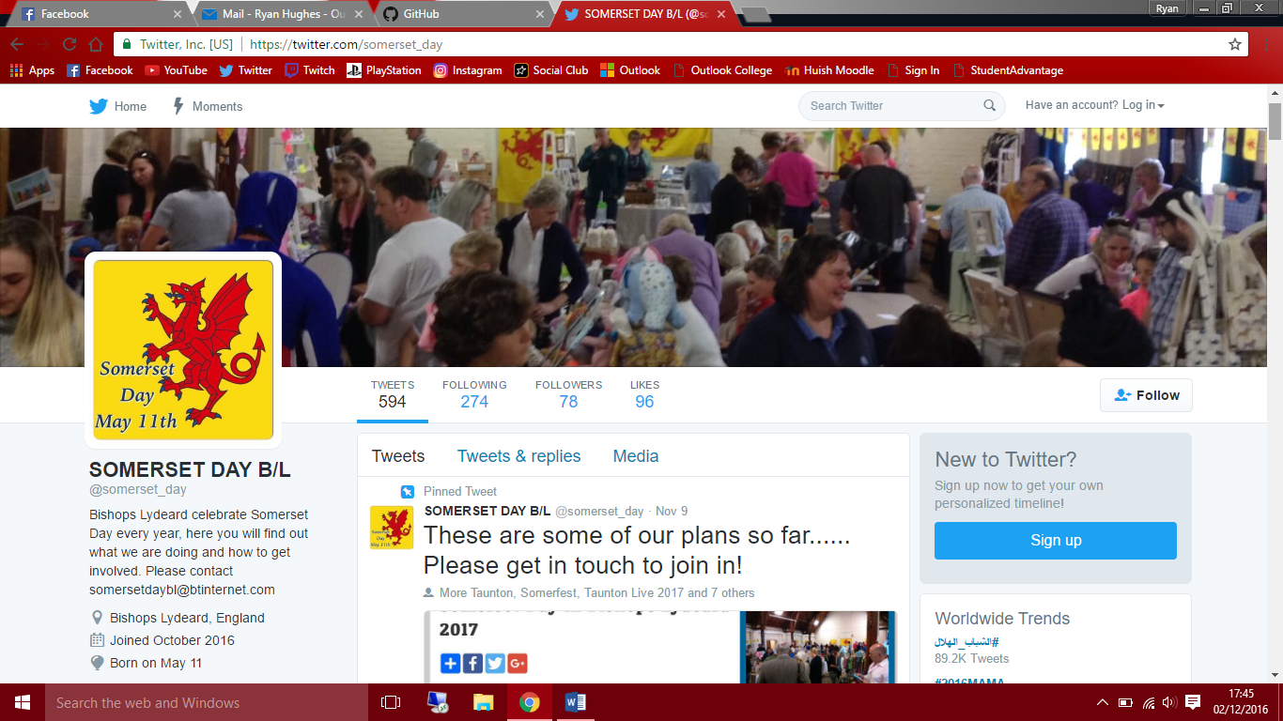Multiple contact details

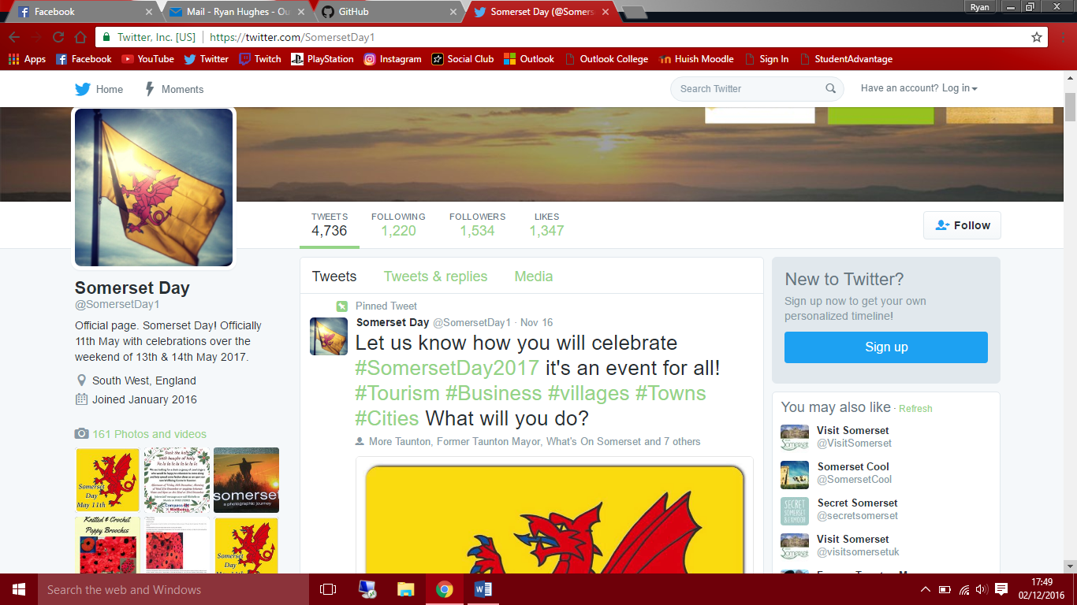Similar to Facebook page

Uses hashtags for interaction

Many images and tweets

Interaction with similar pages

Clear encouragement for hosting an event